

# Sense Inventory Management System

**User Manual**

Last Updated: 2013-3-13

*Developed by*

Loh Hao Bin

(1201A18902)

Table of Contents

Sense Inventory Management System 1

Splash Screen 2

Login Screen 3

Main Screen 5

Menu Bar 5

Main Interface 6

Inventory menu 7

Inventory List 7

Search box 8

Adding New Items 9

Edit Items 10

Deleting a Record 11

Adding Stock Levels 11

Sale of Items (Reduction of Stock) 12

Export or Printing Inventory Lists 13

Suppliers Management 14

Adding New Suppliers 15

Editing Existing Suppliers 15

Deleting Existing Suppliers 16

Items Categories Management (Admin only) 17

Transaction Report (Admin only) 18

User Management (Admin only) 19

Adding a new user 20

Removing a user 21

Changing passwords of users 22

Change user types 23

Backing Up the Database (Admin only) 24

Restoring a Database from Backup (Admin only) 25

User Help 26

About 26

Quick Start Guide 27

Help Index 27

Common Errors 28

Glossary 29

Index/Appendix 31

## Splash Screen

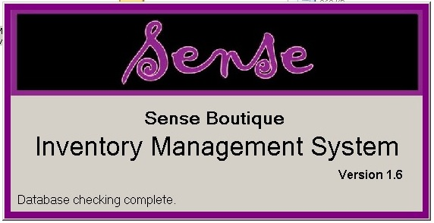

During every startup, a splash screen appears informing the user of the current version number and current loading progress.

It is during this stage that the system checks for the existence and integrity of the database, and performs maintenance operations on the database.

It should go away in a few seconds after the loading operations are complete, and shows the login screen.

If there is a problem with the database, or the database is missing, it will then offer to restore a database from backup (see Restoring a Database for more details) or to create a new one.

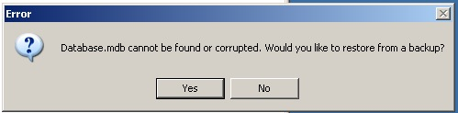

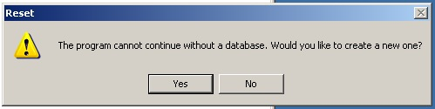

## Login Screen

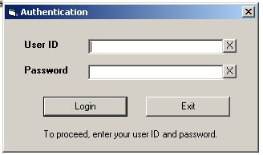

This is the login dialog where an authorized user can input his/her login ID and password to gain access to the system and database.

To login, simply type in the User ID and password, and then click Login.

The X buttons beside the User ID and Password fields allows the user to clear the respective input fields instantly.

Usernames and passwords are case sensitive, and there is a limit of maximum five login attempts per session, to prevent password guessing, after which the system will quit automatically.

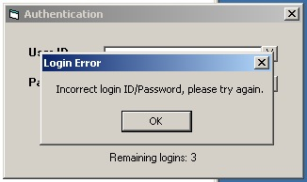

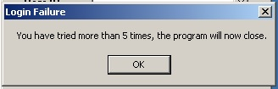

## Main Screen

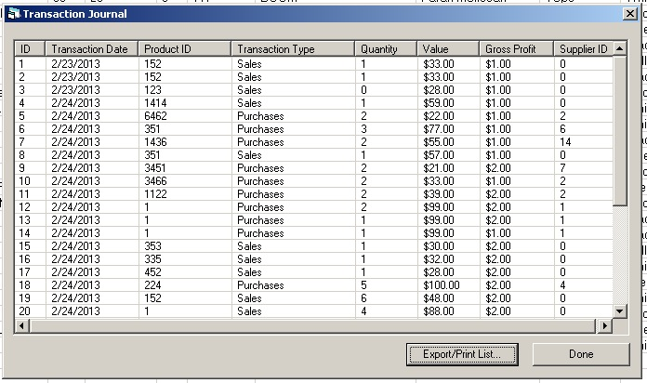After the user has inputted the correct username and password, they will be greeted with the **main screen.**

The main screen is where the user can access all features of the system through various buttons and menus. At startup, the system will automatically load the main inventory list window.

### Menu Bar

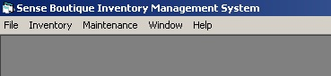

The menu bar contains links to allow the user to access various features of the system. The **Maintenance** menu is only visible to a user with administrator privileges.

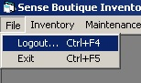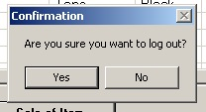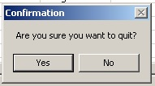

The File… menu contains two options for the program: Logout and Exit.

- Logout… logs out the user, to allow another user to use the system.

- To log out: File > Logout… > Choose ‘Yes’

- Exit… quits the system.

- To exit: File > Exit > Choose ‘Yes’

## Main Interface

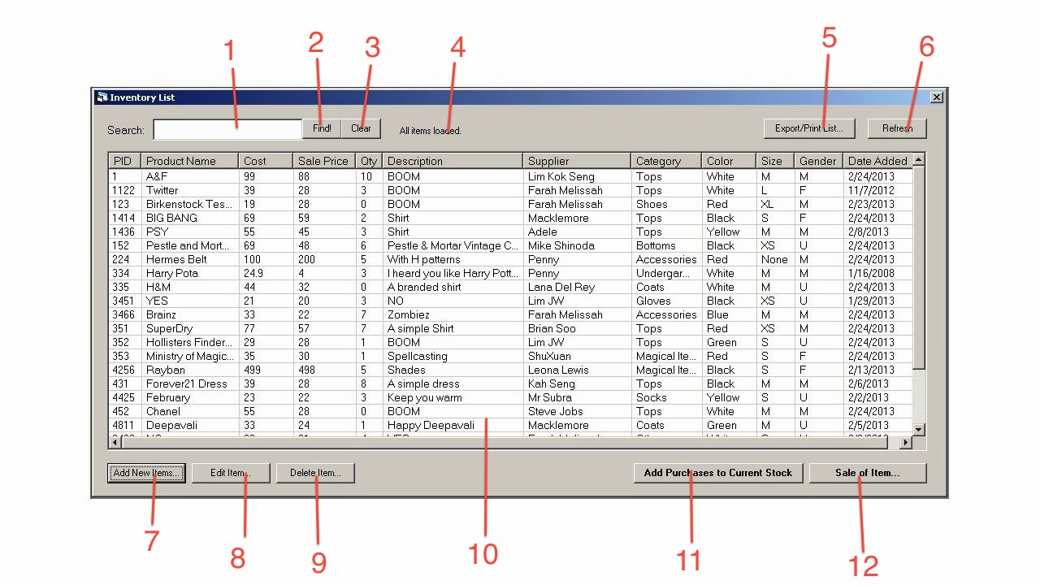

1. The Search box – Allows the user to search for an item matching the search term. Automatically filters as the user types.
2. Search button (“Find!”)
3. Clear button – Clears the search box
4. Status
5. Export/Print List – Opens up a Preview window to allow the user to print or save the inventory list into a text file.
6. Refresh button – To refresh the list view if it doesn’t refresh automatically
7. Add New Items… - To open up the Add New Items window to allow the user to insert a new stock record.
8. Edit Item… - To open up the Edit Item window to allow the user to edit selected existing records.
9. Delete Item… - To delete a selected existing record.
10. The inventory list view – Displays all the stock records currently recorded in the database.
11. Add Purchases to Current Stock… - To add quantity of stock to existing stock records for stocktaking purposes.
12. Sale of Item… - To record a sale of an item to renew the stock record for that item.

## Inventory menu

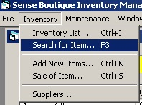

The inventory menu contains most of the options related to the stock record database.

## Inventory List

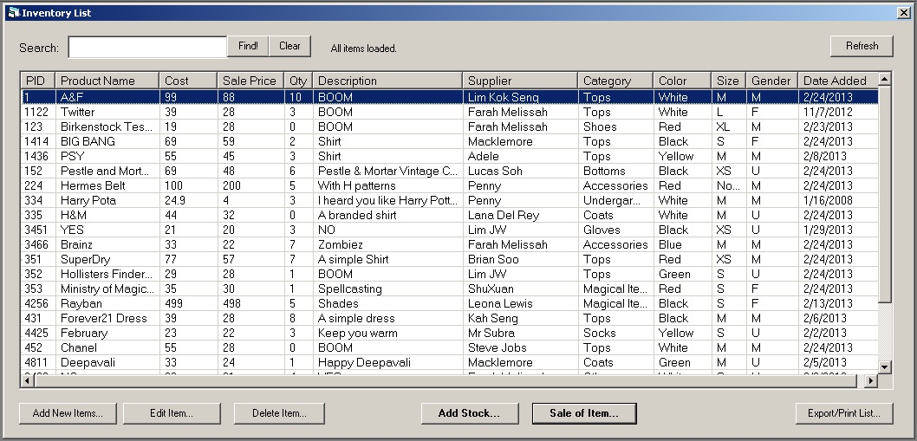

This is the main inventory list window. It lists all the current stock records in the database, with options to add newer items, modify existing ones, delete existing items, or search through them. It provides the user easy access to all records and information at a glance.

This window loads by default during startup, however the user can access it through 2 ways:

- Go to the Menu Bar, open Inventory menu, select Inventory List…

or

- Press Ctrl + I to bring up the Inventory List window

Sometimes, the inventory list view may not display the latest records or changes due to some problems. To force the system to reload data from the database, press the **Refresh** button in the top right corner.

## Search box

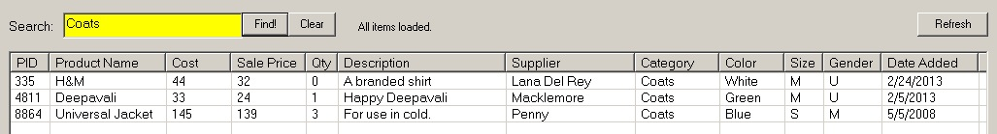

To search for items, simply click on the search box (or press F3 to focus on the search box), the search box will turn yellow, and the user can now type into the search box.

The results matching the search term will automatically be filtered and displayed as the user types. It will match according to Product ID, Product Name, Description, Category and Color.

To clear the search box, press the Clear button, and the list view will return to its normal view, displaying all items at once.

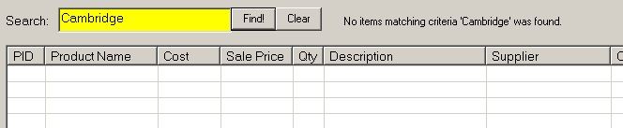

If there are no items matching the search term specified by the user, the status will change to notify the user that no results are found.

## Adding New Items

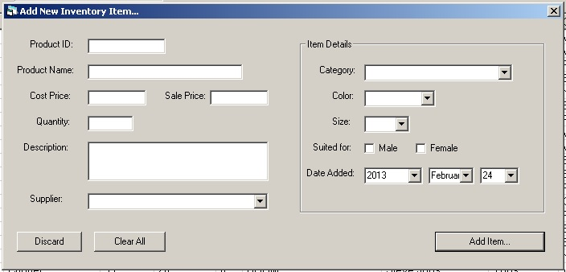

To add a new item, press the Add New Item… button in the Inventory List window (or press Ctrl+N). A new form will show up.

Input all the required information into corresponding boxes, and press Add Item… button. The system will notify the user if the operation is successful, and ask if the user wants to add another new record.

If there is an input error (e.g accidentally input of alphabets in the item cost field, the system will notify the user of the error.

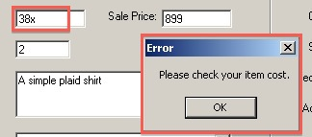

To discard all the information and not add any new records, press the Discard button.

To clear all the information inputted, press the Clear All button.

## Edit Items

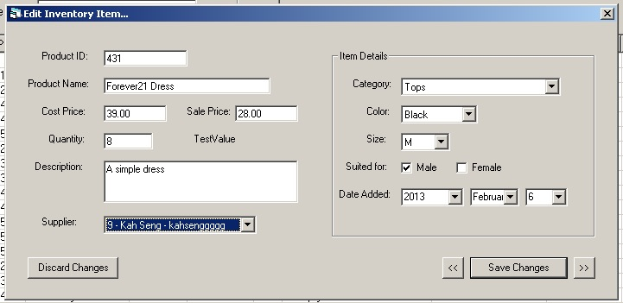

To edit a specific record, **select the record** in the Inventory List window by clicking on the item, and press “Edit Item…” button. The Edit Inventory Item… window will show up.

In this window, the user can change the details, and after the user has finished all the changes, press **Save Changes** to commit the edit. A dialog will appear to inform the user of successful changes.

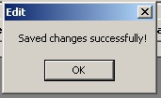

The user can scroll to the previous or next records through the use of the “<<” and “>>” buttons.

*Please note that pressing the “<<” and “>>” keys will NOT save the changes automatically. Hence, please press the Save Changes button before you proceed to the next item.

If the user wishes to revert changes and not save the changes, press the Discard Changes button.

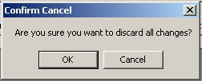

## Deleting a Record

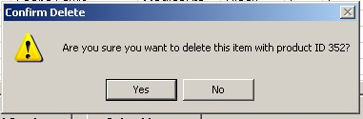

To delete a specific record, select the record in the Inventory List window, and press the “Delete Item…” button.

A confirmation dialog will pop up and ask if the user wants to delete the item with specified product ID.

Press “Yes” to delete the record, or “No” to cancel the delete operation.

*Note: Please double check and confirm the item you are intending to delete, because deleted records are irrecoverable, unless you restore from an earlier backup!*

## Adding Stock Levels

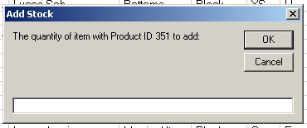

If there are new stocks coming in for an item already existing in the database, the user can just select the specified existing item in the Inventory List window, and press “Add Purchases to Current Stock” button. A new dialog will show up and the user can input the quantity to add to existing stock levels.

If the user inputted non numerical values or other extreme values, an error dialog will show up.

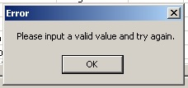

## Sale of Items (Reduction of Stock)

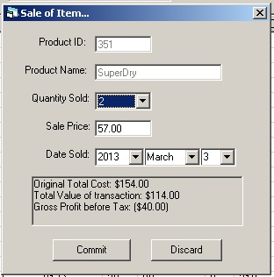

To record a sale so that it would reflect an updated stock level, select the record in the Inventory List window, and press “Sale of Item…” button.

The Sale of Item window will show up, and the user can then choose the amount sold and input the value of the transaction, as well as the date of transaction. Press the Commit button to save.

This will update the stock level and record it in the Transaction Journal. (See **Transaction Report** for more details.)

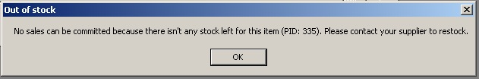

If the user has selected an item with 0 stock left, the system will notify the user of the item being out of stock.

## Export or Printing Inventory Lists

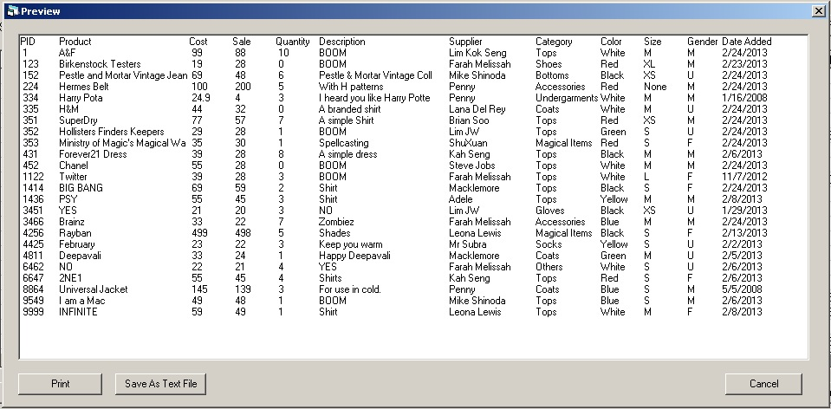

To print or save a list of all inventory records in the database, press the Export/Print List… button in the Inventory List window.

A preview window will show up generating a preview, arranged in table form of all the items in the list.

To send it to the printer for printing, press the Print button.

To save it to a text file, press the Save As Text File button. A text file named InventoryOutput.txt will be generated and saved in the application directory folder.

To exit, press Cancel.

## Suppliers Management

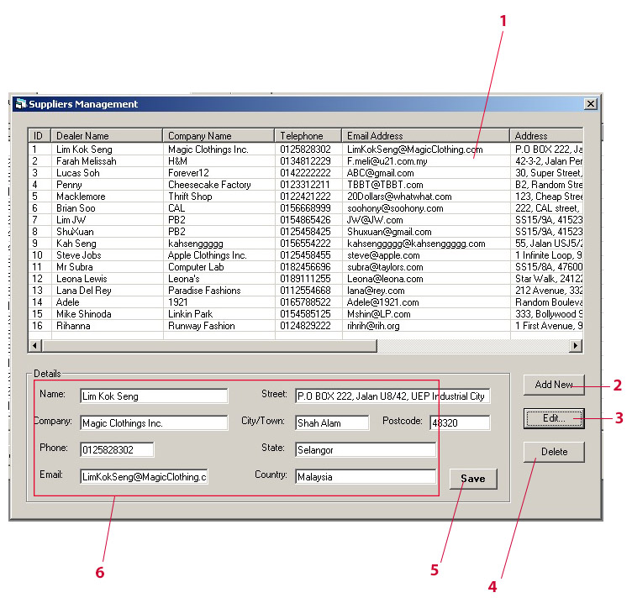

1. List of suppliers
2. Add New… - To add new suppliers
3. Edit… - To edit existing suppliers record
4. Delete – To delete existing suppliers record
5. Save – To commit edits or save new records.
6. Details of the supplier

### Adding New Suppliers

1. Press the Add New button.

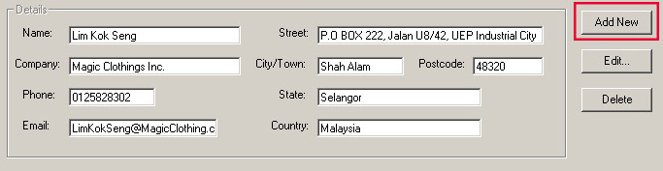

2. The details will be emptied, and a Save button will appear.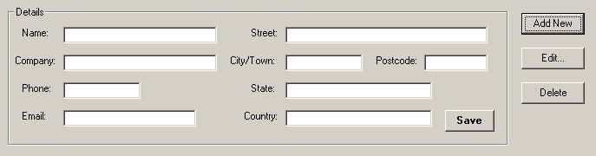

3. Input all the details of the supplier.

4. After finishing inputting the details, click the Save button to save it to the database.

### Editing Existing Suppliers

1. Select a record from the main list view, and press the Edit… button.

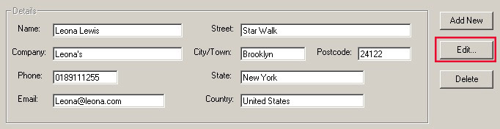

2. The details text boxes will become selectable and editable, and a save button will appear. 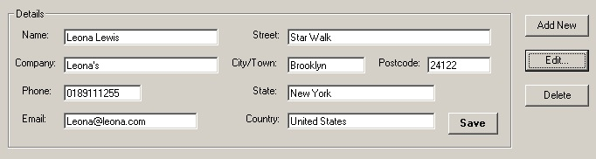

3. Edit the details that you would like to change.

4. After editing the details, press the Save button the save it to the database.

### Deleting Existing Suppliers

1. Select a record from the main list.

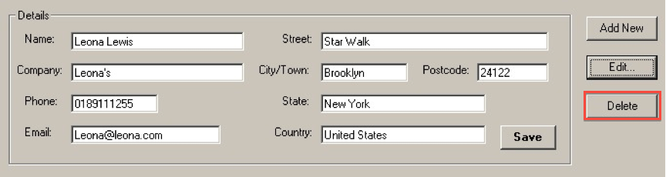

1. Press the Delete button.

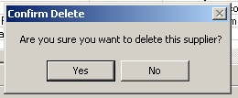

1. Press “Yes” to delete the selected supplier, or “No” to cancel the operation.

*Note: Please confirm that the supplier is the one you intend to delete, as there is no way of recovering deleted suppliers, unless you recover from an earlier backup!*

## Items Categories Management (Admin only)

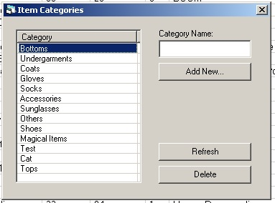

The Item Categories window allows the system admin to manage the categories of items available in the database. The available categories are displayed in a list form.

These categories will be used for displaying the stocks, adding new items and editing.

To open up this window, go to Maintenance > Item Categories…

To add new categories, type in the category name and press “Add New”.

To refresh the list from the database, press the Refresh button.

To delete a category from the database, select the category and press Delete.

## Transaction Report (Admin only)

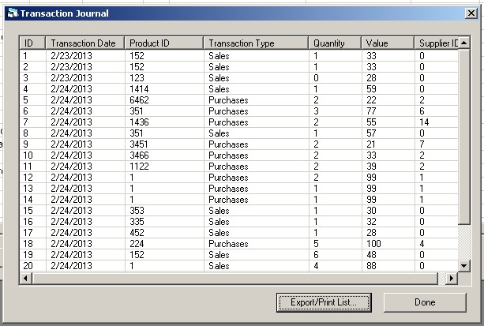

The transaction report window shows a journal of all incoming and outgoing stocks for managerial purposes.

To open up the transaction report, go to Maintenance > Transaction Report… or press F7.

To export or print a list of the journal entries, press the **Export/Print List…** button.

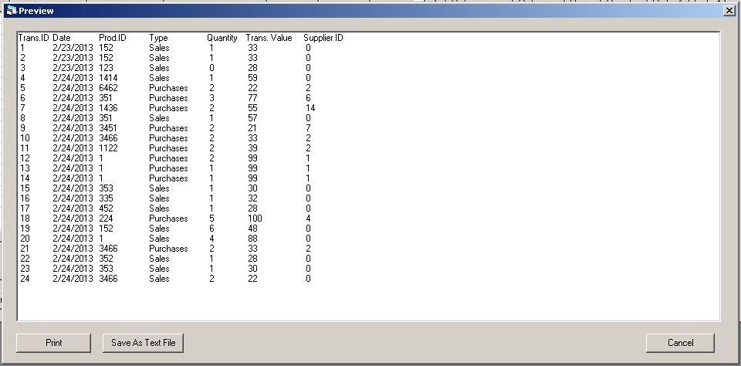

A preview window will show up generating preview for the journal report.

To send it to the printer for printing, press the **Print** button.

To save it to a text file, press the **Save As Text File** button. A text file named JournalOutput.txt will be generated and placed in the application directory.

To exit, press Cancel.

## User Management (Admin only)

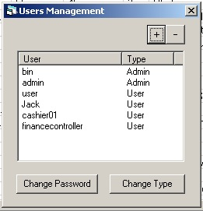

The user management window allows the admin to manage the users authorized to login to the system.

To open up the users management, go to Maintenance menu > Users Management, or press F8.

*Note: The maintenance menu is only available to Admin users.*

### Adding a new user

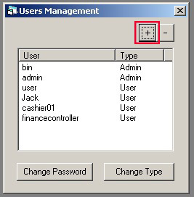

1. To add a new user, press the “+” button at the upper right corner of the window.
2. A “Create New User…” window will show up.

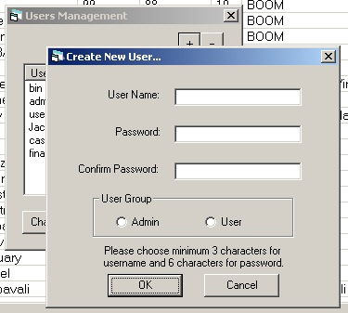

1. Fill in the desired username and password, and then select the preferred User group for the user: Admin or User.

*Please choose a minimum of 3 characters for username and minimum of 6 characters for password, for security purposes.

*Please note that the username and password are case sensitive.

*Administrators have access to the Maintenance menu to perform system maintenance functions, transaction journals and backup/restore procedures.

1. Press the OK button to create the user.

### Removing a user

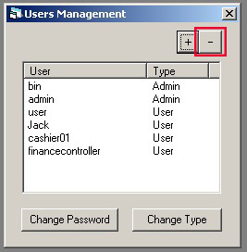

1. To delete a user, select a particular user, and press the “-“ button.
2. A confirmation dialog will appear.

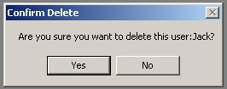

1. Choose ‘Yes’ to delete the user, or press “No” to cancel the operation.

*Please note that deleted users are irrecoverable, unless you restore to an earlier database.

### Changing passwords of users

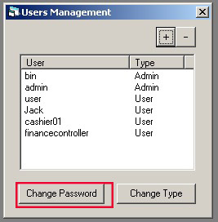

1. To change passwords for a particular user, select the user and press “Change Password”.
2. A change password window will appear.

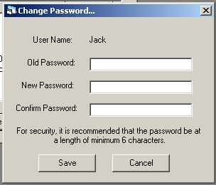

1. Fill in the old password and select a new password for the user.

*\*For security purposes, please choose a minimum of 6 characters for the password.*

1. Press Save to commit the password changes.

*\*Users: Please remember your password, as the passwords are encrypted in the database, and are irrecoverable unless you get an administrator to assign a new password for you!*

### Change user types

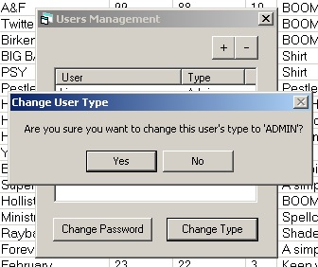

To change the type of the user, select the user in the list, and press “Change Type”.

A user will then be changed from user group “User” to “Admin” and vice versa.

Difference between Admin and Users:

- The administrator can access the Maintenance menu.

- The administrator can add or change categories of items.

- The administrator can add, manage or remove users, and assign new passwords, as well as change user types (promoting a user to admin and vice versa)

- The administrator can perform backup and restore operations.

- The administrator can view the transaction journal.

## Backing Up the Database (Admin only)

Backup is an operation that creates copies of the existing database and save it elsewhere in a remote location or external media for safekeeping purposes, for data recovery in event of a database corruption, data loss, damage, fire, accidents or natural catastrophes.

It is recommended that backup be performed at least once every few days or once a week.

1. To open the Backup/Restore dialog, go to Maintenance menu > Backup/Restore, or press F9.

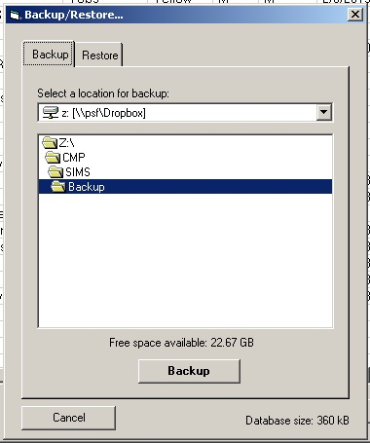

1. Choose the location for backup.

*By default, the location would point to the program’s directory backup folder.

*It is recommended to store your backup on an external media or at remote locations to prevent data loss in event of accident or disasters.

1. Press the Backup button to start the backup process.
2. A confirmation dialog will show up to confirm starting backup.

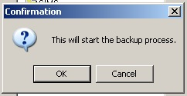

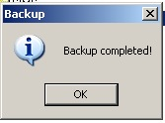

## Restoring a Database from Backup (Admin only)

1. To open the Backup/Restore dialog, go to Maintenance menu > Backup/Restore, or press F9.

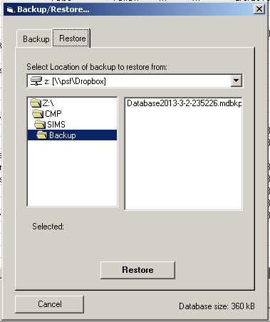

1. Select the location of your backup

*By default, the system points to the /Backup folder in the application directory.

*If you cannot locate your backups, your backups may be stored in external medias.

1. Press the Restore button.
2. It will confirm restore with the user, press “Yes” to restore the database from the specified backup, or “No” to cancel the operation.

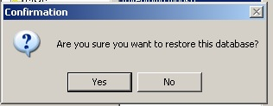

*Note: After restoring to a previous backed up database, all the data in the existing database will be lost and any changes that happened since the last backup will also be lost. Please consult your system administrator before performing any restore operations.

## User Help

### About

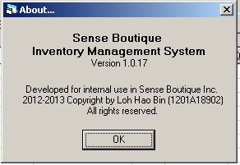

To find out about the current system version, and other legal information, access Help menu > About… to view the About dialog.

### Quick Start Guide

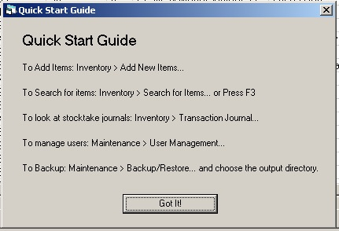

The system provides a quick start guide on how to use the system. To access, go to Help menu > Quick Start Guide or press F1.

Quick Start Guide:

1. To Add Items: Inventory > Add New Items…
2. To Search for items: Inventory > Search for items or press F3
3. To look at stocktake journals: Inventory > Transaction Report
4. To manage users: Maintenance > User Management
5. To backup: Maintenance > Backup/Restore and choose the output directory.

### Help Index

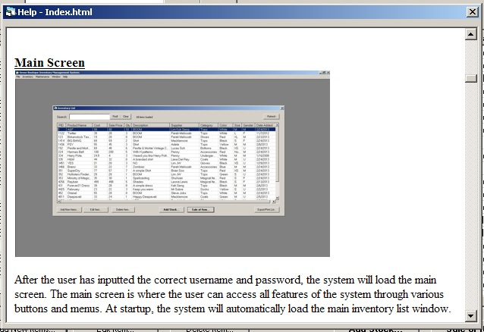

The system also provides basic help documentation for the user. It can be accessed by going to Help menu > Help Topics, or press Ctrl+F1.

The user can then read more about the system and get help on various problems they encounter.

## Common Errors

This is a list of most common errors that can be encountered throughout the usage of the system, however this list is not exhaustive, and your error encountered may not be present on this list.

|  |  |
| --- | --- |
| **Errors** | **Explanation/Possible Solution** |
| “Database cannot be found or corrupted.” during splash screen. | The database file may be damaged, or simply missing. Press OK to restore from a backup or Press Cancel to allow for the option of recreating a new database. |
| “Incorrect login ID/password, please try again” | 1. The login ID doesn’t exist in the database. 2. The password is incorrect.   Please take note that all IDs and passwords are case sensitive. |
| “Please select the quantity sold” when adding a new sales. | You have selected 0 for quantity sold.  Select a quantity sold. |
| Error 482: The print spooler service is not started or printer is not configured properly. | 1. The print spooler service is not started.   Solution: Start > Run > Type [net start “Print Spooler”]   1. Printer is not installed properly. Contact system administrator for assistance. |
| No sales can be committed because there isn't any stock left for this item (PID: Product ID). Please contact your supplier to restock. | There are no more stocks left for a sale to take place. To solve this, add more stock. |
| Please enter a valid value and try again. | You have entered a zero value or non-numerical value into the input box. |
| Invalid value entered. | You have entered an invalid value into a form, e.g. putting alphabets into numerical textboxes. |
| *Null Value* or *Missing Value* in certain fields | Certain linked information has been deleted from the relevant tables and the system cannot find the item specified.  E.g. Supplier A is deleted from database; stocks linked to supplier A might show “Missing Value” in their *Supplier* field. |

## Glossary

**Administrator** – abbr. Admin, the person responsible for managing the system.

**Application Directory** – The folder in which the application is located.

**Backup** – Make duplicate copies of the database file to another location to prevent data loss in case of fire, accident or disasters.

**Database** – An organized collection of tables that stores data and information in a way that a computer program can access easily.

**Delete** – The process of removing or erasing a piece of data.

**Directory** – The structure in which files and folders are stored on a hard drive.

**Encryption** – The process to encode a file or other sensitive information in such a way, so that it is illegible to hackers or eavesdroppers, and only the intended recipient or the person with the key (e.g. passwords) can read it.

**Export** – A process of saving information onto an external file.

**Help Index** – Documentation for users to access in case of needing help.

**Inventory** – Stocks, the items that the business holds for trading or resale purposes.

**Log in** – To allow access to the system to authorized users.

**Log out** – To exit the current logged in session to allow other users to log in.

**Password** – A secret word or string of characters that is used for user authentication to prove identity.

**Print** – A process of reproducing texts and images on paper using a printer.

**Purchases** – The acquiring of goods or stocks from a supplier/dealer.

**Refresh** – Reloading information from the database.

**Restore** – To copy a working copy of database file from backup location to its original location to be accessed by the system in case the current database is corrupted or damaged.

**Sales** – The act of selling a good or stock to another customer.

**Search** – To find an item matching the specified criteria.

**Shortcut** – A combination of keystrokes that allow the user to call upon certain functions easily and quickly, without having to traverse menus using the mouse.

**Splash Screen** – A screen that appears while the system is loading.

**Transaction Report** – A journal of stock inflow and outflow.

**User ID** – A unique name that a user uses to represent him/herself.

**User (Group)** – Refers to a regular user of the system that does not manage the system.

**Window** – An on screen dialog that presents various options and the interface to the user.

## Index/Appendix

A

Add New Items Pg.5, 6

Add Stock Level Pg.5, 8

Admin Pg.12, 13, 14, 15, 16, 17

B

Backup Pg. 16

C

Categories Pg. 12

Clear Search Pg.5

D

Delete Item Pg.5, 7

E

Edit Item Pg.5, 7

Export List Pg.5, 9, 13

H

Help Pg. 18

I

Inventory Pg.3, 4, 5

L

Login Pg.2

P

Print List Pg.5, 9, 13

R

Record Sale of Item Pg.5, 8

Restore Pg.2, 17

S

Search Pg.5, 6

Splash Pg. 2

Suppliers Pg.10

T

Transaction Report Pg.8, 12

U

Users Pg.13